Assignment – 6

1. Create a case and add a path to the case object using the Salesforce setup. Also, add the fields such as account, case number, contact email, etc to the case object. Finally, activate the path.
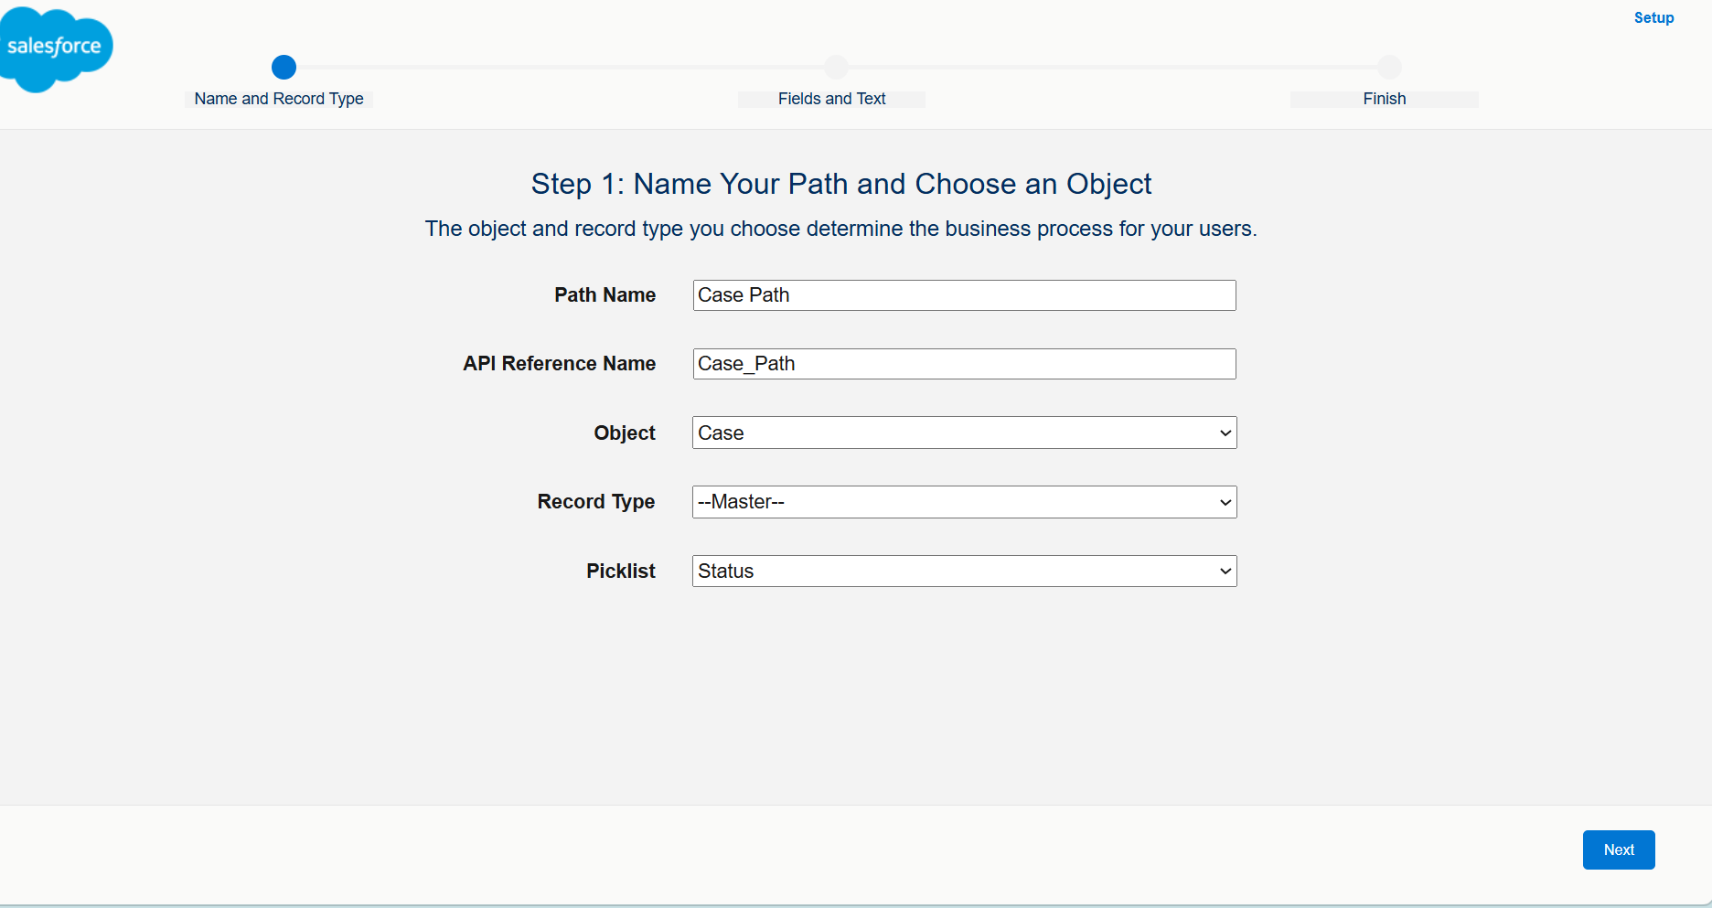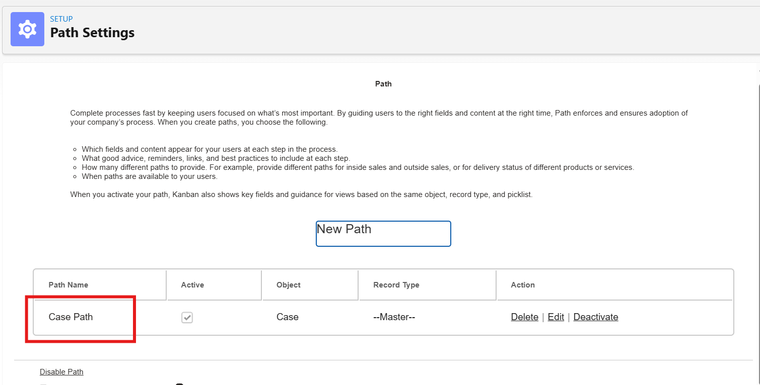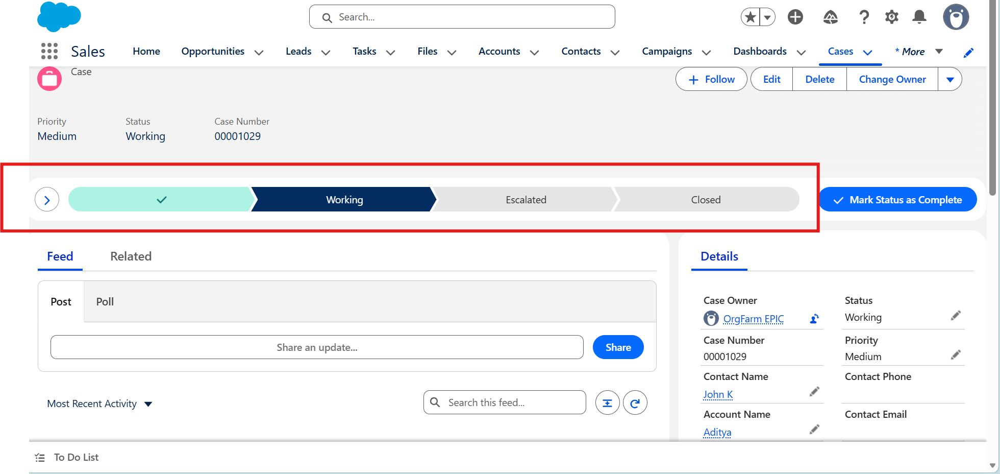
2. Enable web to case option in Salesforce and set the case origin as web. Generate a form using the web to case html generator and create a case using the form.
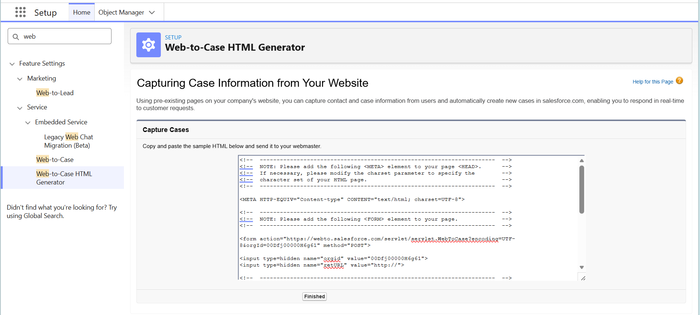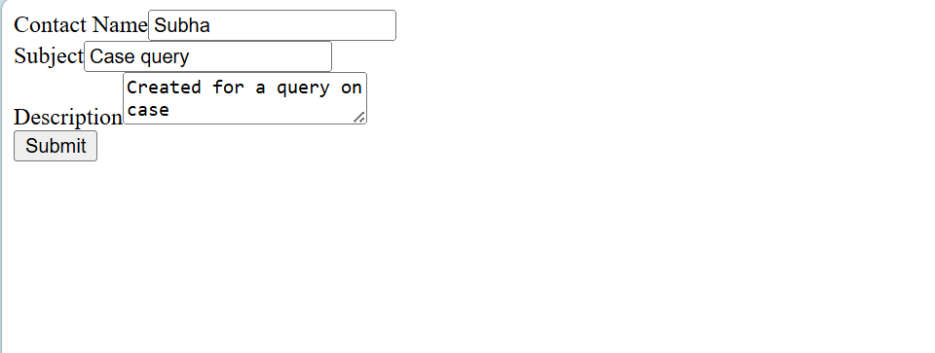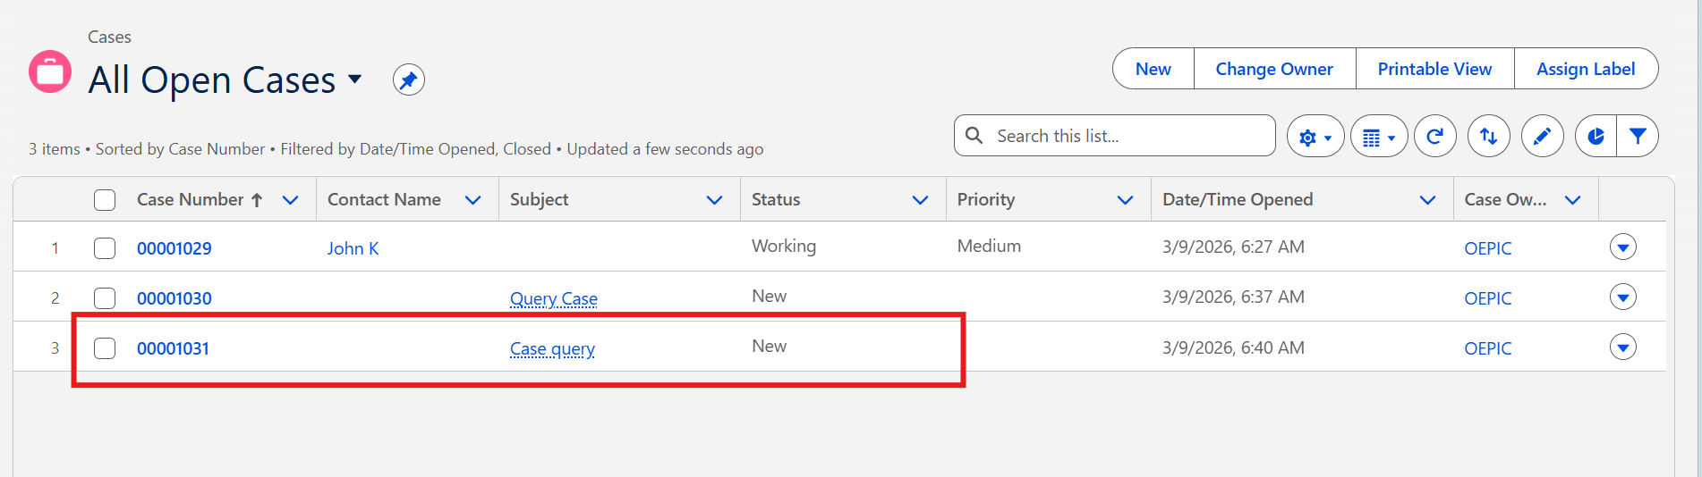

3. Create a case assignment rule along with rule entry where case origin equals web and sort order is 1.
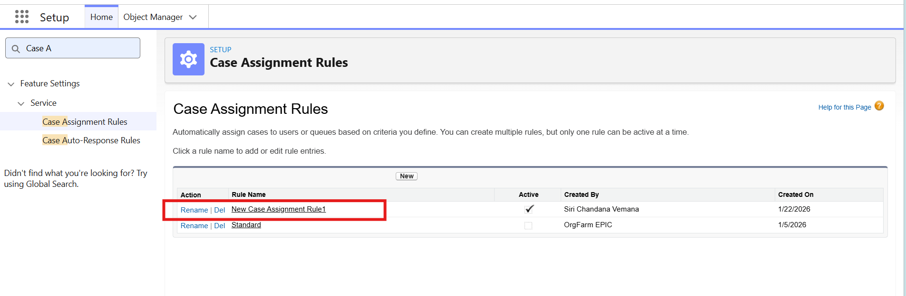
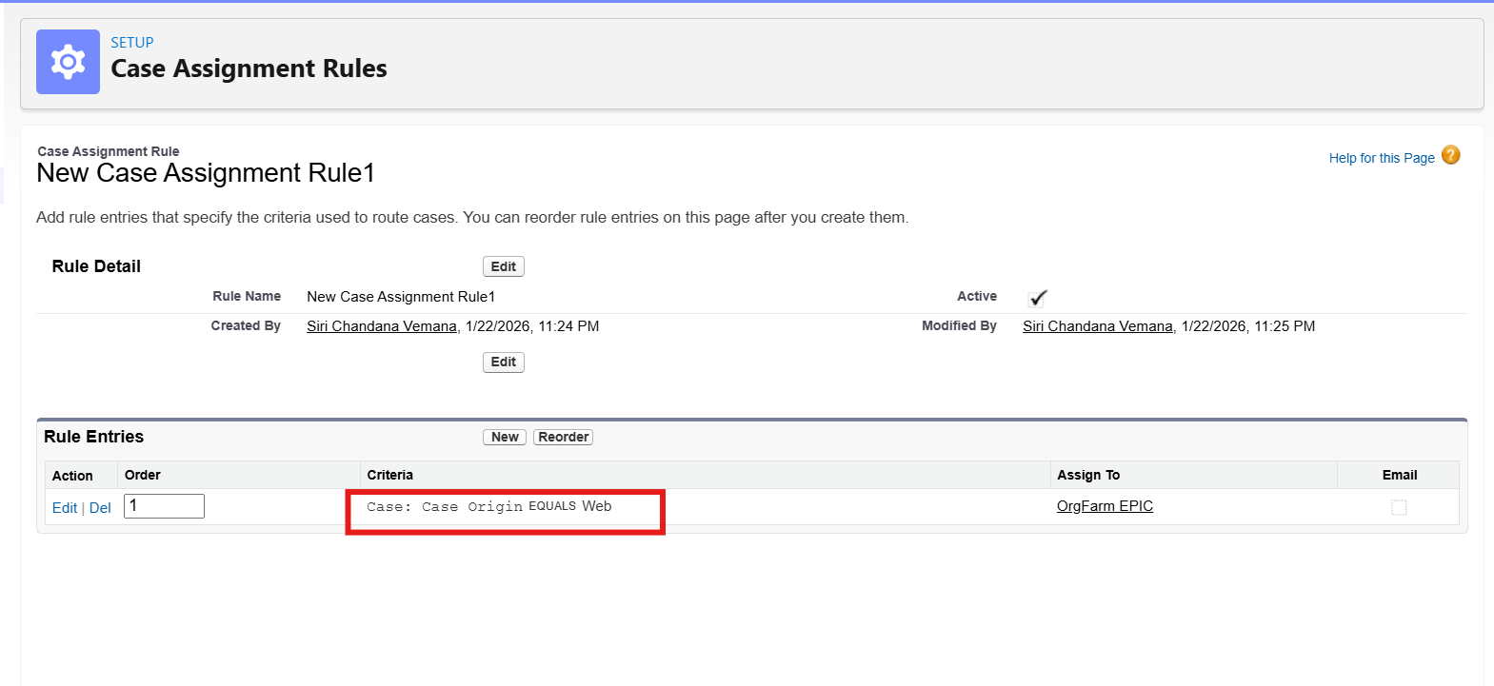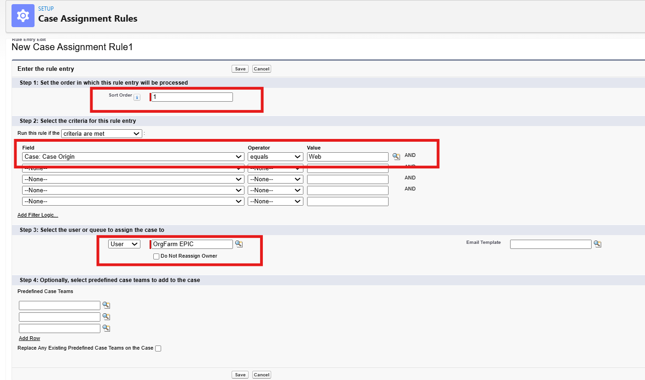
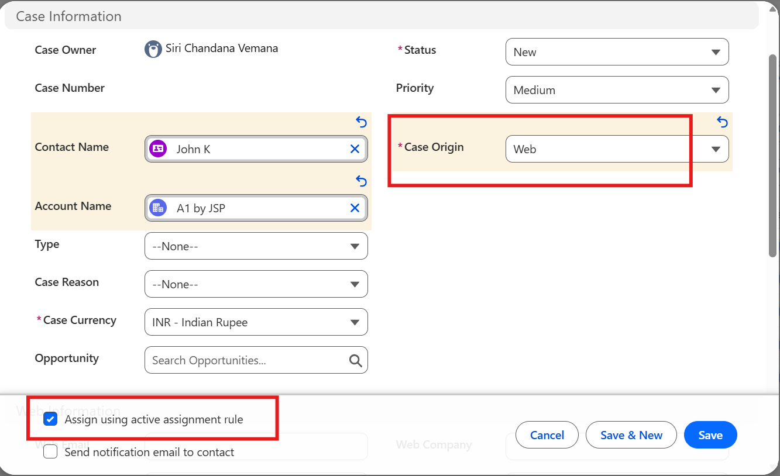

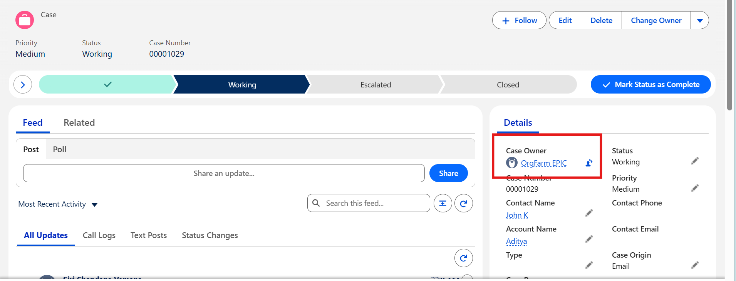

4. Create escalation rule and its related rule entries where case origin is web with sort order as 1. Also create the escalation action where a time criterion is 30 min and specify the user.
